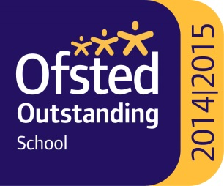
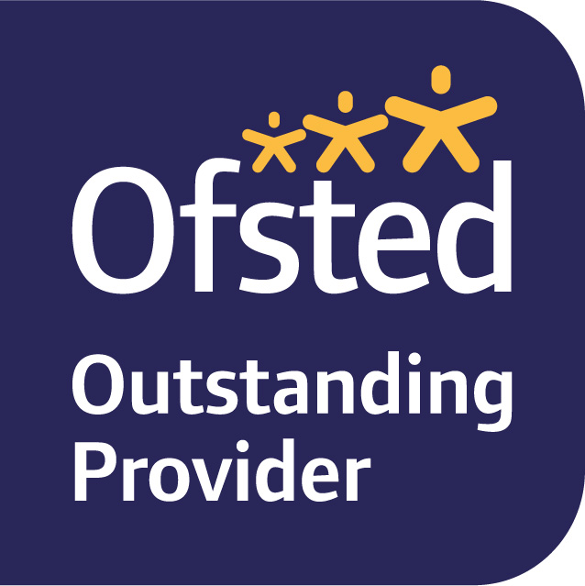
Bacup Nursery School
Cowtoot Lane
Bacup
OL13 8EF

Tel 01706 873856
head@bacup.lancs.sch.uk

Headteacher: Mrs A Cooper, BA Hons, QTS, NPQH




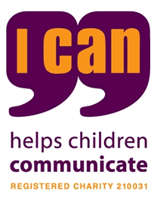

SEND Information Report (September 2025)

SENCo-Miss B Proctor
SEN Governor-Sarah Coupe
Contact: becky.proctor@bacup.lancs.sch.uk

Bacup Nursery School is a maintained nursery school in Bacup, Rossendale within Lancashire County Council.
The nursery school is led by a headteacher and employs qualified teachers (QTS) who follow a graduated response to the learning needs of all the pupils who attend the nursery school.
Bacup Nursery School makes provision for children with SEN within each of the four categories identified in the 2014 Code of Practice:
- Communication and Interaction
Some pupils experience difficulties when communicating and interacting with others. This can take several forms, for example, difficulties in sound production, limited use and understanding of words and phrases and/or underdeveloped skills in communicating with others.
- Cognition and Learning
Some pupils face difficulties when learning. There are a number of reasons why some children find aspects of learning more challenging ranging from specific issues eg dyslexia or dyscalculia to wide ranging difficulties that can affect all areas of development eg poor memory skills, or processing difficulties. Each child is treated as an individual and needs are met accordingly.
- Social, Mental and Emotional Health
Some pupils require additional support with their personal development to overcome various social, emotional and behavioural barriers to their learning. We value a nurturing philosophy at Bacup Nursery School which underpins the way we understand and support each pupil.
- Physical and Sensory
Some pupils have physical and/or sensory needs which require the curriculum and environment to be adapted in order that they can fully access learning opportunities.

How does the school know if children/young people need extra help and what should I do if I think my child/young person has special educational needs?
At Bacup Nursery School, the attainment and progress of all children is carefully tracked and monitored. This process is overseen by the Head teacher who holds termly progress meeting with class teachers to discuss each child’s progress. On a daily basis, teachers evaluate teaching and learning, and consider whether individual children are making the expected progress.
When staff raise concerns, they are discussed with the SENCO and parents are invited to come into school to share the concerns that school hold. Parents are encouraged to speak initially to their child’s class teacher if they have concerns.
A graduated approach to overcoming difficulties is put into action. Children’s needs are assessed by experienced class teachers, the nursery school SENCO, and by other professionals from outside school. This includes health visitors, speech and language therapists and the specialist teaching service.
Pupils are placed on the SEN support register when it is agreed that they have area(s) that need support/intervention, in addition to that given in quality class teaching. Regular dialogue between all staff involved, and parents, ensures the needs of the pupil are reviewed and progress is accelerated wherever possible. Pupils with SEND are assessed using the Bacup Nursery School Stage A curriculum, which tracks small steps of progress. This assessment provides staff, parents and other professionals with an age-related assessment in months of development.
Some children have complex needs and a multi-team approach will be used in requesting an EHC plan and meeting the targets set within it. Parents, and the pupil, will be significantly involved during this process. Other agencies involved will also be included where necessary.
What arrangements does the school make for consulting with children/young people with special educational needs and disabilities about - and involving them in - their education?
When supporting children with SEN, we aim to talk to our children and fully involve them in the process. We discuss their individual targets and progress with them and make sure we celebrate their achievements with them, however big or small.
For children with an EHC Plan, we always share their views within the Annual Review process. These views may be discussed with them before the meeting or if appropriate, children can come into the meetings to share their views. We use a range of practical and visual strategies to support children who find it difficult to express their views with words. Wherever possible, we try to take into account the views, wishes and aspirations of our pupils when discussing outcomes for the child and approaches to achieve them. When children are non-verbal or unable to communicate their views verbally, we gather information from parents to contribute to the child’s voice.
What arrangements does the school make for consulting with the parents & carers of children/young people with special educational needs and disabilities and involving them in their child's/young people's education?
At Bacup Nursery School, we recognise the value of working in collaboration with parents and carers of children with SEN in order to achieve the best outcomes for them. As a maintained school, we strive to ensure a high level of communication with parents so that they feel well informed about what is happening in school and how their child is progressing. This includes sharing Target Learning Plans and reviews, parent’s meetings, progress meetings and annual reports. We have an ‘open door policy’ where Teachers and SENCO are always happy to meet with parents at a mutually convenient time.
For children with Education, Health and Care Plans, parents will be invited to attend their Annual Review meeting in which children’s progress against their individual targets is looked at in detail and decisions about future provision is jointly agreed. Parents are involved in the process of applying for and Education, Health Care Plan, by completing their child’s one page profile, discussing the intended outcomes of the plan with the SENCO and completing the parental advice information to be submitted with the application.
How will the curriculum be matched to my child/young person's needs?
The SEN Code of Practice (2014) recognises that ‘Special educational provision is underpinned by high quality teaching and is compromised by anything less.’ At Bacup Nursery School our priority is ensure that all children, including those with SEN have access to good or outstanding teaching which is appropriately differentiated and personalised to meet the needs of individual children.
Differentiation can be observed in a range of ways. At Bacup Nursery School, we strive to accommodate all learning styles and provide appropriate resources, often with the advice of other agencies for the children with special educational needs.
Teachers use Wellcomm for speech and language development and our highly effective and sequential curriculum has been designed by the headteacher and senior leaders in the nursery school who have a sound and in-depth knowledge of typical child development that enables them to quickly identify where children may need additional support in their learning and development. A targeted learning plan (TLP) may be written to describe the extra help a child may need to reach the next steps in their learning. This will be delivered through key worker interaction in 1-1 situations or small group time. Where appropriate, children on the SEN register will have designated time to work towards their TLP targets in our specialist ‘Cabin’ provision. The Cabin is a calm and quiet space with high quality resources, chosen to support children’s development in the prime areas of learning. Targeted learning plans are reviewed regularly with the key worker/teacher delivering the interventions along with the SENCO and new targets are agreed. Reviewed targeted learning plans are shared with parents.
Teaching assistants are allocated carefully according to their skills and experience., Teaching assistants play a vital role in teaching and learning and are provided with high quality continuing professional development to enable them to support children more effectively in their roles as key workers.
How accessible is the school environment?
The nursery school is a ground level building and has a disabled toilet and changing area. Ramps make the building fully accessible indoors and outdoors. An environmental audit can be carried out if a child has specific physical or sensory needs that impact on their ability to access the learning environment or opportunities.
How are the school resources allocated and matched to children/young people's special educational needs and disabilities?
How is the decision made about the type and quantity of support my child/young person receives?
The budget is carefully managed by the Headteacher and Governing Board to make decisions regarding the most effective allocation of resources. This includes human and physical resources.
Pupils with EHC plans have provision listed clearly in their plan which is met by internal and external sources. EHC plans are reviewed annually, including the level of support required and its impact. All relevant parties are involved in the review process.
Additional funding can be applied for through the Early Years Inclusion Fund which is managed by Lancashire County Council. Parental permission is requested before making an application for inclusion funding. Inclusion funding is used to provide higher levels of adult support for children with target learning plans and to resource specialist equipment, when needed.
How will both you and I know how my child/young person is doing and how will you help me to support their learning?
At Bacup Nursery School, we recognise the value of working in collaboration with parents and carers of children with SEN in order to achieve the best outcomes for them. As a school, we strive to ensure a high level of communication with parents so that you feel well informed about what is happening in nursery school and how your child is progressing. This includes termly parent’s meetings, termly progress meetings and annual reports.
We encourage parents to be part of the progress their child makes and advise them where necessary of how to support this at home. We have an ‘open door policy’ and teachers are always happy to meet with parents at a mutually convenient time, as of course is the SENCO.
Where children have a TLP (Targeted Learning Plan), this will be shared with parents so that they can support learning at home. Each child has their own Learning Journal which demonstrates children’s progress and achievements, and we encourage parental contributions to Learning Journals.
For children with Education, Health and Care Plans, parents will be invited to attend their Annual Review meeting in which children’s progress against their individual targets is looked at in detail and decisions about future provision is jointly agreed.
What training have the staff supporting children/young people with SEND had, or may they have?
Staff members have had training in a range of areas including communication skills, social skills groups, circle times, Makaton signing, nurture and attachment, sensory needs, autism and memory skills.
Prior to a new pupil with particular needs starting nursery school, we endeavour to find out as much information from their parents/carers and previous school/nursery as we can in order to have provision in place.
Children have access to a range of additional provision. This includes:
- A highly skilled SENCo who is a qualified teacher
- A headteacher who has significant experience in specialist education
- Qualified teaching assistants who are highly qualified, trained and experienced
- All staff are Paediatric first aid trained
Children’s communication skills are assessed on entry to nursery school and this can lead to some children accessing specific early intervention activities in groups or 1:1. We refer to Speech and Language therapy, if necessary
- Receive regular visits from a specialist SEN teacher from Lancashire SEND team to assess specific needs, provide advice and resources to teachers/teaching assistant and support the SENCO in providing for all the children with SEN support or EHC plans.
How will the nursery school prepare and support my child/young person to join the school, transfer to a new school or the next stage of education and life?
We have an induction process to support children as they start nursery school. Parents receive a New Starter meeting with a designated member of staff before the child starts nursery school where key information is shared and parents can ask any questions. We offer Open Days so that children and parents can come to see the environment and meet the staff before starting. On a child’s first day, parents stay with the child for a half an hour visit. Teachers are given time to meet and share information about each child, including effective approaches and strategies for meeting the needs of children with SEN. Where necessary, children with SEN may make extra visits to their new classroom and are supported to prepare them for the changes ahead. Induction is discussed between parent and teacher to ascertain if a child may need longer to settle.
Bacup Nursery School aims to provide children with the skills to be prepared for the next stage of education i.e. primary school. We maintain good links with local primary schools and welcome visits from primary school staff to support the move to primary school. Our SENCo will arrange a meeting with primary school teachers and the SENCo to support transition and will share all relevant information.
How will my child/young person be included in activities outside the classroom, including school trips?
At this school, we pride ourselves on providing an inclusive learning environment where all children including children with SEN are treated equally and have access to the full range of opportunities that we provide. We run extra-curricular clubs after school and try to ensure that all children who want to participate are able to. Some children will need additional support with particular skills so they are supported by adults or their peers.
All children are included in any educational visits. Children are considered individually regarding the support they need e.g. 1:1 adult, walking frame etc. Access arrangements are included in the risk assessments and the parent and pupil are included in these discussions, where appropriate, so that they feel secure.
During lunch times, children with SEN are able to play outside with their peers. There are covered areas for those who prefer to sit and play with friends or alone, rather than run around. In more challenging situations, we have adults supervising certain pupils during these times. All staff, including welfare assistants, are briefed on individual needs.
What support will there be for my child/young person's overall well-being?
Bacup Nursery School has a nurturing ethos. The head teacher, SENCO and class teachers are significantly experienced in promoting, supporting and developing children’s well-being. The school strives to develop and support the positive wellbeing of all our pupils.
At Bacup Nursery School, we provide individual additional support for children, and families, on issues such as managing emotions, dealing with separation or maintaining friendships. We have close links with other who are able to provide specialist support such as counselling when a referral is agreed necessary.
For children with medical needs, we work alongside parents, paediatricians, health visitors and specialists to ensure correct care is in place. We have health care plans which are regularly reviewed. (See Medical Policy for information on administering medication). All staff are Paediatric first aid trained.
We are proud of our inclusive school where all children accept and support each other. We encourage and expect empathy and understanding from pupils and staff at all times. However, we are aware that children with special needs are vulnerable and therefore we observe their well- being closely. We have a clear Behaviour Policy and Behaviour Expectations which are communicated to children consistently.
All children are entitled to participate in all areas of school life regardless of ability or needs. We believe our provision of high-quality learning experiences enrich children’s overall education.
How do you evaluate the effectiveness of the provision made for children and young people with special educational needs?
At Bacup Nursery School, we have a robust system of self-evaluation in which we evaluate:
- Quality of Education
- Effectiveness of Leadership and Management
- Personal Development,
- Behaviour and Attitudes
As part of this process, we evaluate the effectiveness of the provision for pupils with Special Educational Needs. The SENCO and SEN governor meet to discuss the provision for children with SEN. The governors also receive regular reports.
Each term the performance of all children, including those with SEN is analysed by the Head teacher, SENCO and Senior Leaders and areas of need are identified. In addition, interventions are regularly reviewed and monitored to ensure that the impact is effective.
Parents are kept informed, as previously mentioned, throughout the year.
How do you involve other bodies, including health and social services, local authority support services and voluntary organisations, in meeting the needs of children/young people with SEND and in supporting their families?
School
Head teacher: Mrs Andrea Cooper
SENCO: Miss Becky Proctor
SEN Governor: Mrs Sarah Coupe
External agencies
We have strong links with a range of education, health and social care professionals who can support the process of assessment, target-setting and ensuring that the needs of children with SEN are appropriately met. This includes working with:
Special Educational Needs and Disability Officer(SENDO)
Our school SENDO is Nicola Fielden
Educational Psychologists
Speech and Language Therapists
Advisory teachers
Occupational therapists/Physiotherapists:
Children in need of OT or physio input need to be referred by their GP or paediatrician. If a programme is required, we are able to support parents by following the programme in school too.
Medical practitioners including health visitors, paediatricians and the Child and Adolescent Mental Health Service(CAMHS) team.
Social Workers from Lancashire County Council and other agencies.
-Professionals from local Children’s centres.
What arrangements do you make in relation to the treatment of complaints from children/young people and their parents/carers with special educational needs concerning your provision made?
At Bacup Nursery School, we are committed to working in partnership with parents and carers to meet the needs of the children in our school.
If parents have questions or concerns about the provision for a child with SEN, in the first instance, we would encourage them to contact the child’s class teacher. Should they then wish to discuss the concerns further, they could contact the SENCo or Headteacher.
In the unlikely event that a concern is not resolved, then please make contact with our Chair of Governors in line with our ‘Parental Complaints’ policy and procedure.
Where can I find the contact details of support services for the parents of children/young people with SEND?
SENDIASS is available for parents to access additional information, support and advice.
http://www.lancashire.gov.uk/children-education-families/special-educational- needs-and-disabilities/help-for-parents-and-carers/information-advice-and- support.aspx
Where can I find information on where the local authority's local offer is published?
Lancashire County Councils Local Offer - http://www.lancashire.gov.uk/send
Bacup Nursery School’s Local Offer is on our School Website at:
www.bacup.lancs.sch.uk

